JUNE 2023
By Chance
Graveside Reflections
Sweet friendships refresh the soul and awaken our hearts with joy, for good friends are like the anointing oil that yields the fragrant incense of God’s presence.
Proverbs 27:9 TPT

I just recently went to North Carolina to conduct the Memorial Service for a long-time friend and former church member who had passed away a few weeks before. In planning and leading the Memorial Service I had a lot of time to think about my friend, his family, our friendship, the love and support he had given to me personally and to our church in more ways than I could count. It was a long drive down, a long drive back and some sacred time shared with family and friends that gave rise to some important thoughts. When one ponders the deep and sacred thoughts of standing before a family that has lost their patriarch and others their dear friend, some things come to mind that ought to be named and thought about more.
When we stand at a graveside and look into a hole six feet deep, eight feet long and three feet wide we think about what truly matters as we stand on the top side of the ground. When we stand in front of people gathered to remember and celebrate the life of a shared friend and family member, we think about what truly matters in life.
For one thing, all the irritations, frustrations, differences of opinions, arguments and disagreements that come with any friendship don’t seem to matter all that much. Looking back, we realize that irritations and frustrations, and differences of opinions are a part of life, a part of any relationship but ultimately don’t define our relationships. What truly matters is the camaraderie, the shared joys, the jokes, the deep conversations, the sharing of two souls that truly matter and that are spoken of at such times. We simply can’t let irritations and differences of opinions get in the way of genuine relationships.
For another thing we realize how often we take our friendships, our shared journeys, our times on the trail of life for granted. How often we fail to appreciate how precious our friendships are and the difference we make in one another’s lives. Work, play, busyness, appointments all pale in comparison to our time together. We may take our friendships for granted, but at the end of our time here on earth nothing is more precious than our friends and family.
In one last reflection I want to share the recognition of our shared relationships, the joy of our friendships and the love of our families. May we always be aware of how important our friends are, may we let nothing supersede our families, and may we use as much of our strength and energy to forge the bonds that last. Several friends of the family of my deceased friend drove many miles, used precious time, and made the effort to be there for their friends. How great is that!
We can’t stand in front of a funeral crowd or an empty grave and not reflect on what’s truly important in life. Take the time and make the effort to make new friends but keep the old, for one is silver and the other gold!
In honor of all the friends that have refreshed my soul.
D. Robert Chance
NEWS AMONG OUR
CHURCH FAMILY

PRAYER LIST

Please let us know if you know of someone who is sick or is a shut-in. Thank you.

Ed & Dolores Wachtman

Bette Cox

Edwina Meheaux – Please keep in your prayers. Give her a call on the phone.

Patty Collins- Please keep Patty in your prayers. She loves telephone calls too.

Michael Lastre – Keep in your prayers

Susan Montgomery – Keep in your prayers

The people of Ukraine- Keep in your prayers

All those who suffer from grief and loss and who struggle with illness in any form.

There are always others—keep all in your prayers, named or unnamed. Let us know if we’ve missed someone.
…

Birthdays & Anniversaries
2 Tracy Miller
7 Roger Crutchfield
13 Sasha Treasure
17 Cassie Chance
20 Kenny Vincent
26 Blake & Amy Buckingham

********
Please let the Church Office know if Your Birthdate and/or Anniversary Date Is Wrong or missing, so we may correct it.

cHURCH DIRECTORY
THE 2023 CHURCH DIRECTORY IS COMPLETE!
yOU MAY PICK UP A COPY IN THE CHURCH OFFICE DURING OFFICE HOURS.
oNE COPY PER HOUSEHOLD, PLEASE.

NEWS FROM OUR MINISTRIES

FELLOWSHIP…Amy Buckingham/Mary Chance
The Fellowship Period is slowly building back up to the joy it was before the Covid Pandemic. We’re so glad to see that. The after-worship Fellowship Period is an important part of church life. Please remember to sign up and provide the Fellowship Period on a Sunday that is open on our schedule and available for you. We like to keep it simple, maybe some coffee, cold drinks, and pre-wrapped sealed cookies or snacks. Keep it Simple! See you Sunday.

PROPERTY…John Small
Currently, the building and grounds remain in good condition with no major problems. The mild winter was a blessing, requiring little work from our fearless snow team. That said, I would like to thank everyone on the snow team for their commitment.

Like any facility, from time to time there are small tasks that need to be done around the church. A few years ago, we had a group of people known as the Carpenters Club that would meet once a month to tackle these tasks. If you are interested in helping out and joining the Carpenters Club, please let me know. Thanks.

Property Ministry Chair, John Small
John.smallmb66@mail.com

OUTREACH…Connie Spoon
It’s hard to believe that our Backpack Drive will begin soon (late July/August). The school supply list will be available in the July newsletter. Our food pantry is minimally stocked at the moment. If you need assistance or would like to donate, please contact the church office.

WORSHIP…Gwen Mott via Carol Knott
During the worship service on Jun3 18 we will celebrate and honor fathers. We know what a blessing having a father or a father figure in our lives is. Some verses in the Bible concerning fathers: Proverbs 22:6: “Start children off on the way they should go, and even when they are old, they will not turn from it.” Ephesians 6:4: “Father, do not provoke your children to anger, but bring them up in the discipline and instruction of the Lord.” Come and join us at worship on June 18.

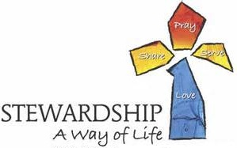
STEWARDSHIP…
Please Don’t forget to send your offering in or place it directly in the offering plate on Sunday morning. You can also mail it to the church or drop it in the mail slot outside the main doors.

Your offering makes the Lord’s ministry possible! Thank you for all you do!

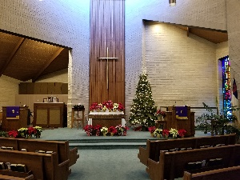

Highlights from the Board Meeting, May 10, 2023
- The meeting was opened with prayer and devotional.
- Treasurer and Financial Secretary Reports were received.
- The Pastor’s Report was received.
- Ministry Reports were shared by the Ministry Chairs and good discussion was held in response to the ministries taking place in the life of the church.
- Upcoming events were reviewed and final details discussed.

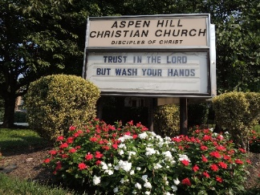
FACTS & FIGURES WORSHIP ATTENDANCE FOR MAY
The good news is attendance is increasing and heading in the right direction. Visitors are being welcomed and contacted as available and able to do so. The bad news is there is a long way to go to reach pre-pandemic numbers. If you haven’t returned yet now is the time and please invite and bring friends and family to join you.

“I was glad when they said unto me, “Let us go into the house of the Lord.” Psalm 122:1
(INCLUDES BOTH IN PERSON AND ONLINE)
May Average Total: 53 (33 in person / 20 online)
Year to Date Average: Total: 56 (34 in person / 22 online)

11:00AM Sunday

The Worship service will also continue to be offered live and online. Keep checking www.aspenhillcc.org, click on the You Tube link and choose the date you want.

Worship in person at 11:00 every Sunday & Live on our YouTube Channel

We are doing our best to get people back in person, but we do understand that some people cannot make it to church on certain Sundays. To view online click www.aspenhillcc.org, then click on the Watch Us Live on YouTube icon. Once at our YouTube Page be sure to click the thumbs-up icon and subscribe to our channel. You can also make any nice comments you want to, that helps us be more visible. Comments help drive our visibility to others up. Share the links for our weekly worship with your friends and neighbors.

Please submit your articles, updates, and information we might like to include in future newsletters
to Cindy for possible inclusion in the future.
The deadline for the newsletter is the third Sunday of each month (May 21 for the June issue.)
----------------------------------------------------------------------------------------

Church Office Hours:
Monday-Thursday 9:00 am-3:30 pm, Friday 9:00 am-1:00 pm

Please let the office know how you want your newsletter delivered! USPS, Email or Both. office@aspenhillcc.org or call 301-871-7222.

June Meetings
Program Council – June 7 @ 7:00pm
St. Paul’s Breakfast – June 11 @ 8:30am*
Board Meeting – June 14 @ 7:00pm

(*Please note change of date)

Help us re-stock our food pantry.
Items needed:
- Canned vegetables
- Canned fruit
- Soup
- Beans
- Juice boxes

Items may be dropped off in the wooden box outside the Fellowship Hall
or bring them to the church office during office hours.
----------------------------------------------------------------------------
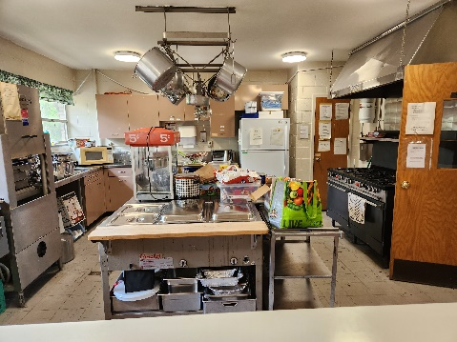
Sprucing Up the Kitchen
Hot Button Campaign
June 1-30, 2023

A generous person will prosper;
whoever refreshes others will be refreshed.

Proverbs 11.25

This year we are focusing on “Sprucing Up the Kitchen” in order to help us update our kitchen with some new and up-to-date appliances; fix and repair some of what we already have in the kitchen; and do a general clean-up in the kitchen. Anything we raise beyond what we absolutely need for the kitchen will go into our General Fund in order to continue making our ministries possible.
This is a wonderful opportunity to make some repairs and replacements that are needed. Thank you for sharing your gift in making this possible. There will be more information coming with weekly mailings and bulletin inserts.
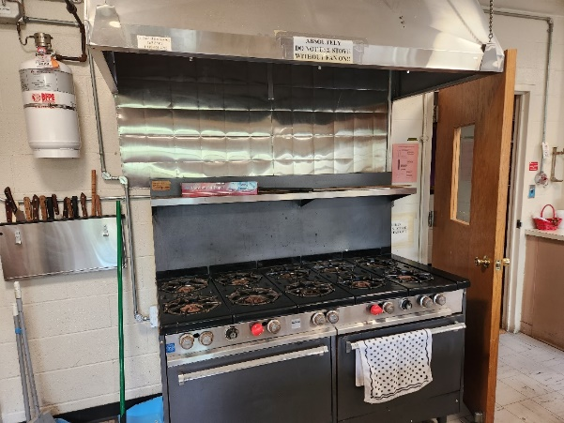
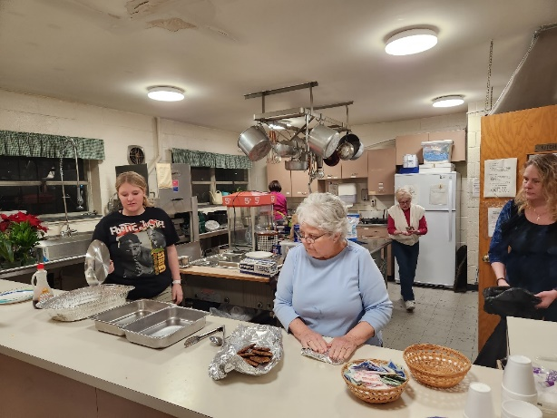

2023 Capital Area Prayer Calendar for This Month
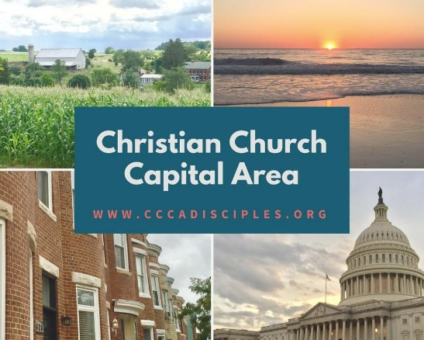
Ephesians 6:18: And pray in the Spirit on all occasions with all kinds of prayers and requests. With this in mind, be alert and always keep on praying for all the LORD's people. You are invited to participate in the Capital Area Prayer Calendar by offering a prayer each day for the listed congregation, institution, or event during the week listed. Please pray for their pastor/executive director, lay leaders, and the community(ies) they serve. Pray also for the missionaries serving the world through our Global Ministries.

For weekly prayers, go online to: http://www.globalministries.org/weekly_prayers [Note: The Capital Area has a special relationship with two missionary sites: China and Colombia] * Indicates a discrepancy b/w what is listed on the Global Ministries website and their printed calendar.

- June 4 The Commission for Camp & Conference and all the campers, directors, counselors, and staff at the Christian Church Conference Center at Bethany Beach Phyllis Byrd, Kenya
- June 11 Henson Valley Christian Church, Fort Washington, Maryland - www.hensonvalleychristianchurch.org Bruce and Linda Hanson, Honduras 3
- June 18 Heritage Christian Church, Silver Spring, Maryland - http://heritagedisciples.com Jeff Mensendiek, Japan
- June 25 Hyattstown Christian Church, Hyattstown, Maryland - http://hyattstownchristianchurch.org Fiona Kendall, Italy

